SEO Audit report

On page

Meta tags:

Title: exists

Description: too long(Length : 438, should ideally be between 70 and 160 characters )

Slug: exists

Heading tags:

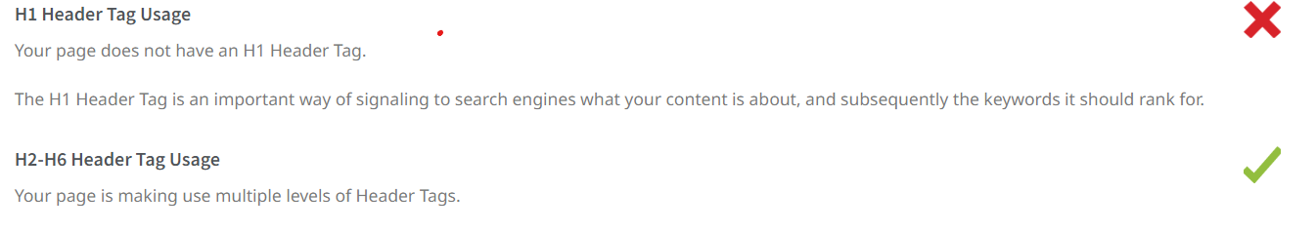

Duplicate content:

Alt tags:

